1. Pop rivets out of casing(26 of them) we lost one of the rivets (not the cap)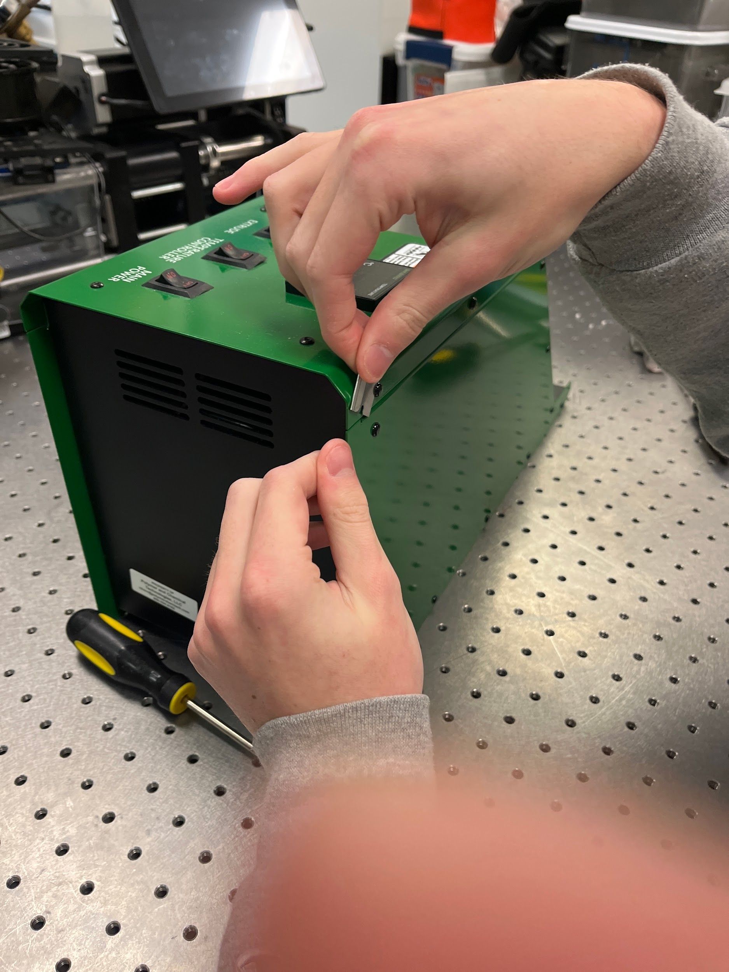
2. Take housing panel on side off
3. Take other side off
4. Slide off insulation panel
5. Unscrew things on top

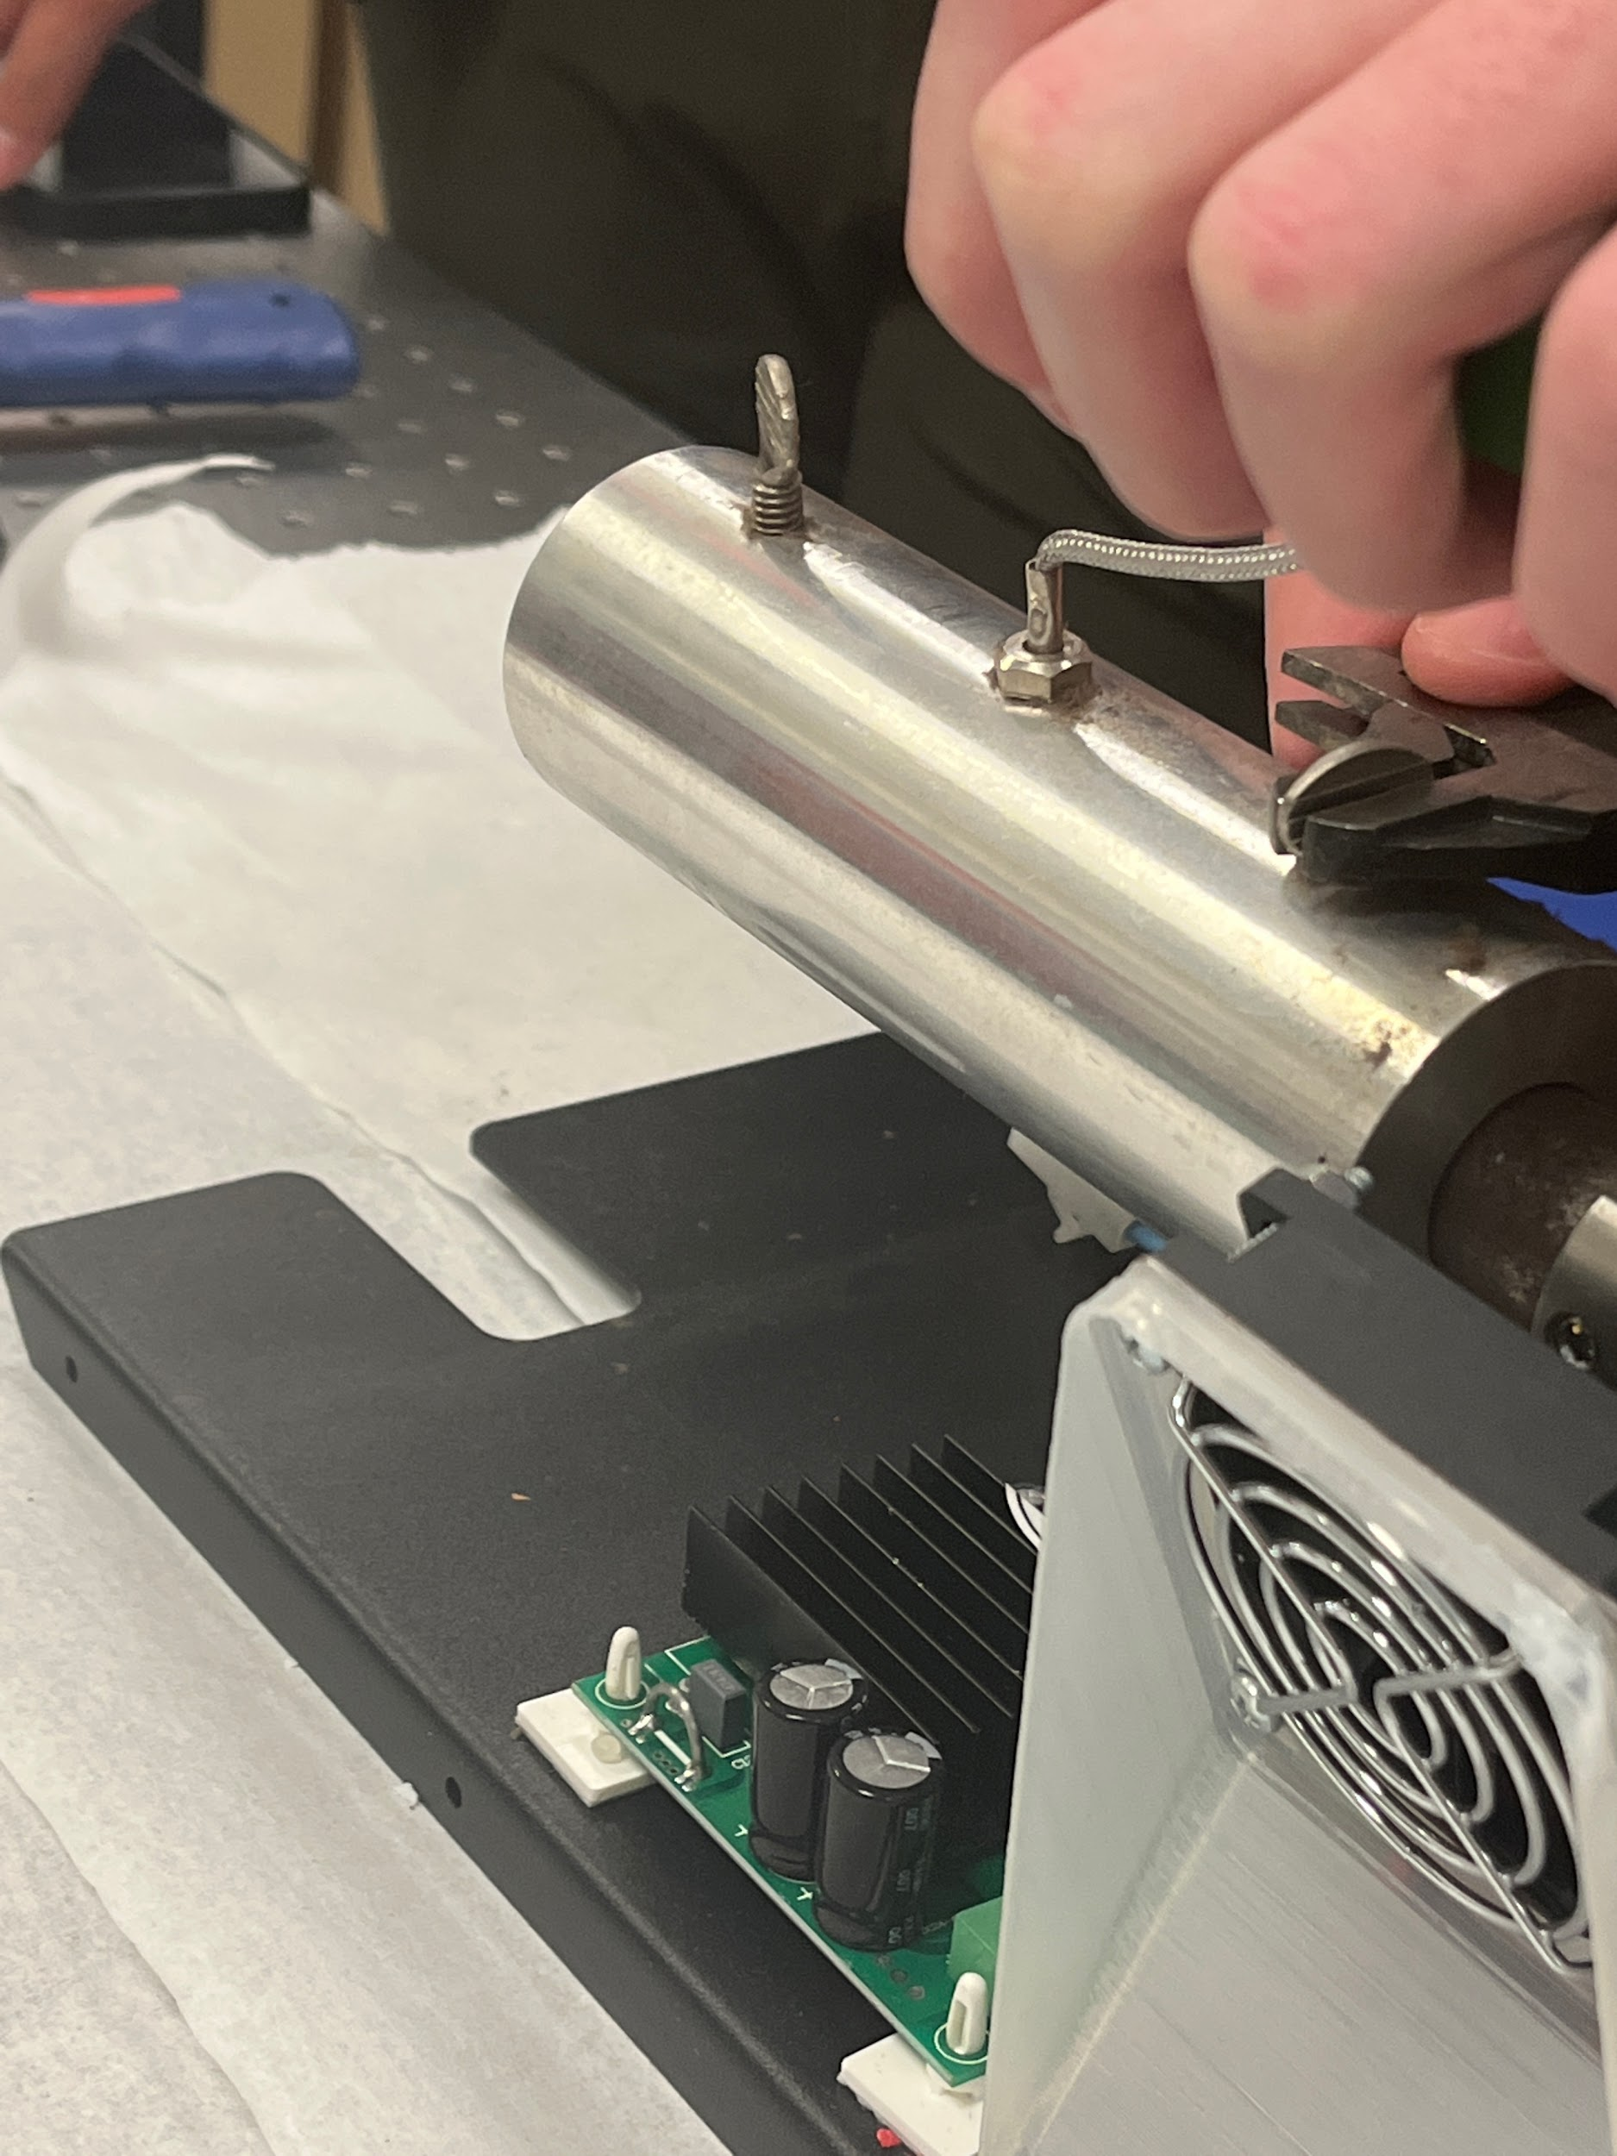

7. Unscrewed zebra screws

8.

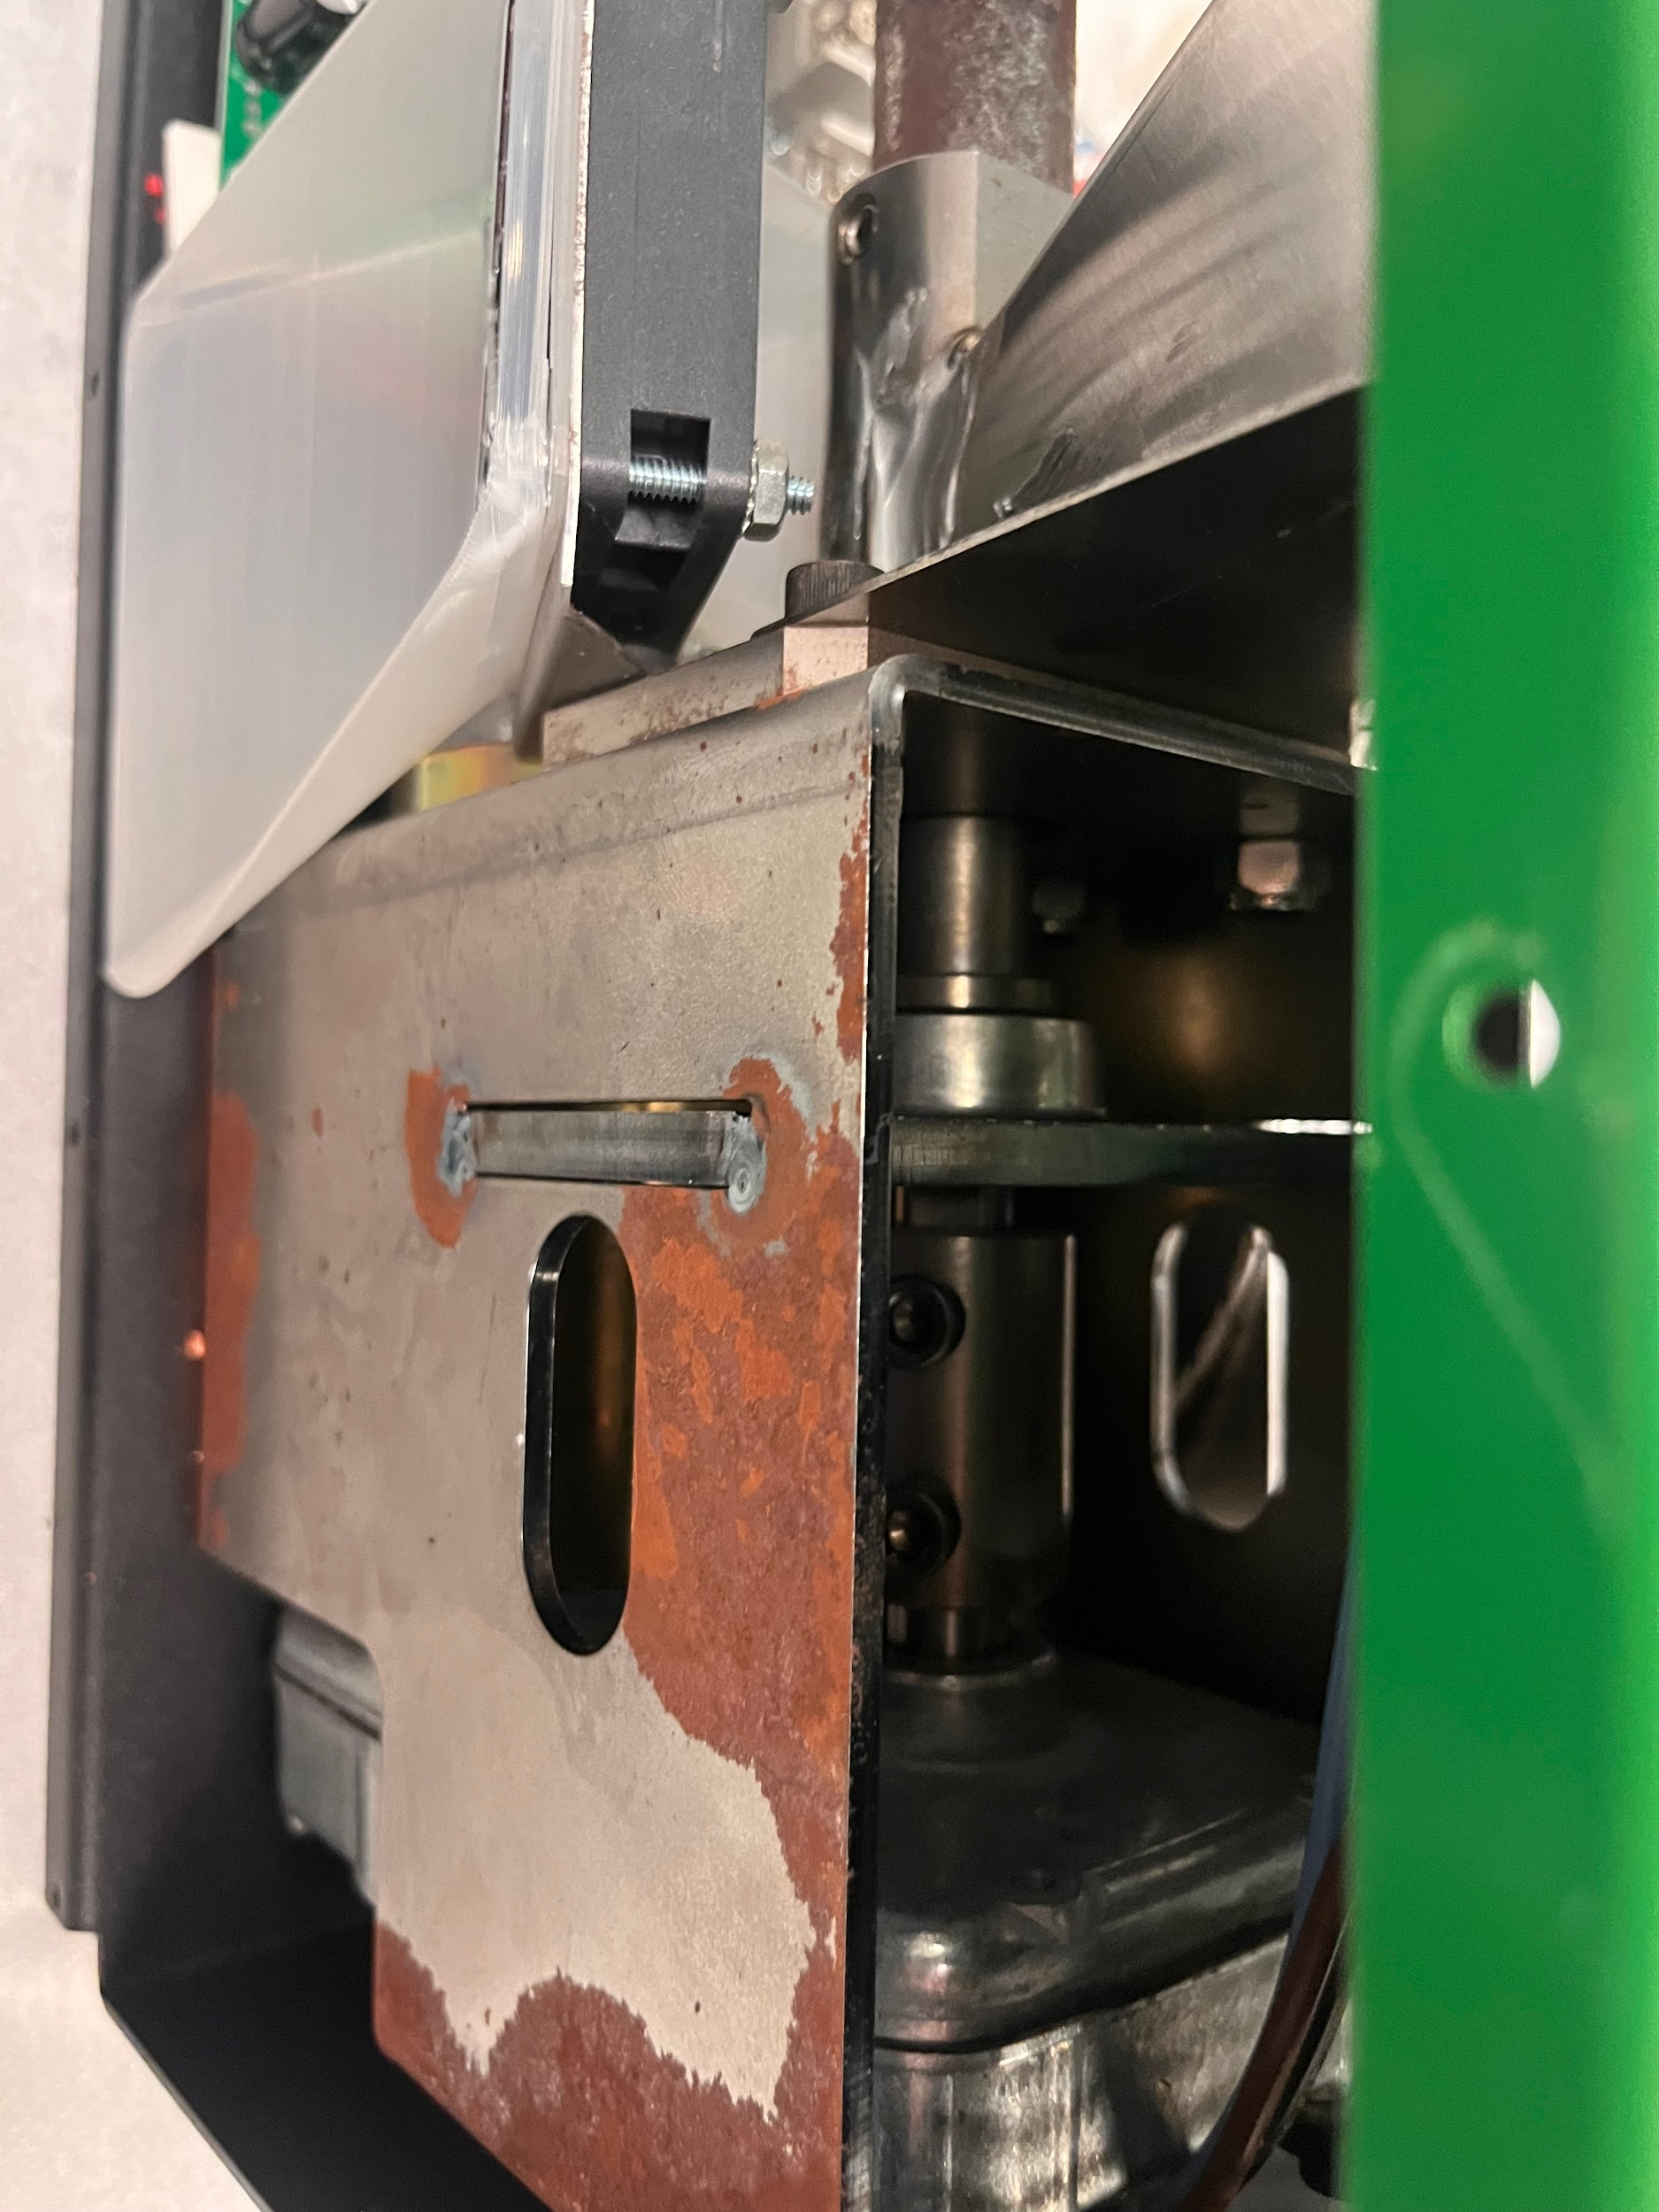

9. Take off cooling fan

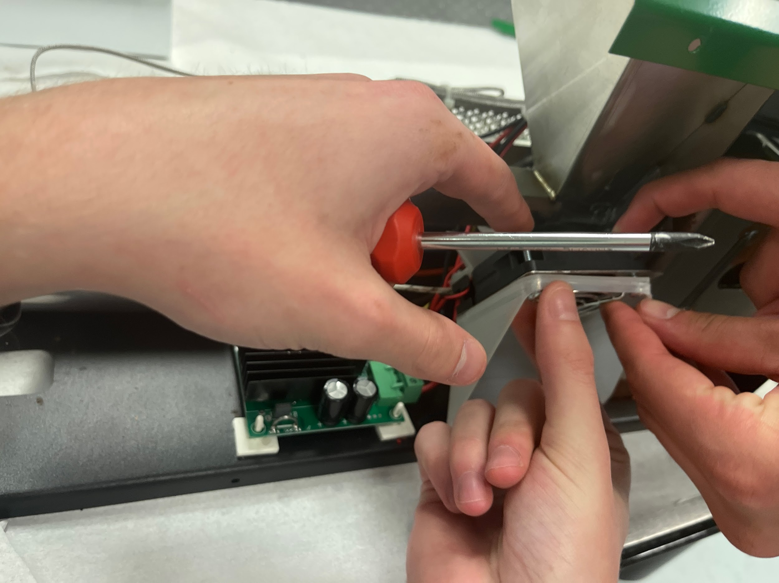

10.

Notes on the design:

This barrel only has support on the end. Since ours will be longer, it will need multiple supports along its length